# People Manager review worksheet

|  |  |  |  |  |  |  |
| --- | --- | --- | --- | --- | --- | --- |
| **Employee name: Mark Atkinson** | | | **Date:** | | | |
| List Performance Goals Below | | Star Rating  *(Click the Stars below to indicate number of stars for each goal.)* | Weighting to total 100% for each section | | Weight based on role to total 100% | |
| **Performance Goals** | **Goal 1:** **Pursue Operation Excellence:** **Deliver on QA Foundational Initiatives**  **Comments:** Working with my assigned teams and with other non-assigned teams, I’ve incorporated focused thinking about and implementation of Quality Metrics, Test & Defect traceability, development of Health check testing, and build acceptance testing. |  | 20% | 100% | 50% | 100% |
| **Goal 2:** **Pursue Operation Excellence:** **Maintain and support Automation standards across assigned teams, and any others I can help with**  **Comments:** I’ve established formal and informal lines of communication with team members and myself.  These two channels have facilitated opportunities for both formal and informal coaching, training, and maintaining the testing & reporting standards supporting operational excellence. |  | 20% |
| **Goal 3: Pursue Operation Excellence:** **Continue building a community of practice that embodies inclusion, sharing and support across teams.**  **Comments:** Utilized scheduled discussions, team member specific expertise, and informal discussions to establish teamwork bonds |  | 20% |
| **Goal 4: Deliver to our Customers: Enhance automation capabilities in conjunction with ongoing enterprise initiatives**  **Comments:** I am building out functionality where we can continually deploy new test framework functionality to existing customers and deploy to new customers as well.  This is an entirely new ability to our customer base. |  | 20% |
| **Goal 5**: **Pursue Operational Excellence: Develop expanded skills and expertise in tooling and technologies**  **Comments:** The underlying skill set necessary to meet Goal 4 has been elevated and improved.  Necessary to accomplish this has required improved knowledge of development environments, debugging in said environments, incorporation and development of build and deployment pipeline tools and adoption of Content Delivery Systems. |  | 20% |
| **Overall Comments Goals** | **Overall Comments for Goals:** 2020 has been a challenging year professionally and culturally.  I’ve had to meet personal deficiencies head on and accept that improvement of my reputation and technical abilities was mine and mine alone to accomplish.  With the received guidance and coaching, I feel comfortable if not proud of a couple of accomplishments this year. |  |  |
| **Competencies/ Employee behaviors** | **Deals Effectively with Change**  **Comments:** I've learned and have a greater understanding of my organization this year.  I deal well with flexibility and change within a range of understanding.  Working this year through difficult projects and process has helped me develop much bigger sense of what can change, and what the landscape of the unknowns are.  Ambiguity is not going away.  This year has helped me to better prepare for what is ahead. |  | All Competencies are weighted evenly. | | 50% |
| **Creates Accountability**  **Comments:** I have made it one of my primary responsibilities with each team member relationships that I treat each person respectfully and as equals with a little less experience.  I do not hold my experience out to any team member other than as example of the possibilities within them.  It is at this point in our relationships where I can explain in their own terms what others will be expecting of them, how they can best communicate successes or difficulties early in the process.  I also let them know how they can use me to assist in their assigned goals and accomplish work they have requested. |  |
| **Focuses on the Customer**  **Comments:** I have always had the perspective that I am doing all my work for the customer.  This year, I have two customers.  Engineers and the Public.  Keeping my relationships with my teams and other interested parties is key to the Test Automation development process that ultimately benefits the public customer |  |
| **Drives for Operational Excellence**  **Comments:** My role this year has allowed me to take on several small opportunities for learning.  I have put them to use.  I have several more lined up.  In my conversations with team members I always keep the idea of added learning of something small yet significant every week. My coaching on technical tasks always incorporates how we will start working on a new task will not be the ultimate way we finish the task.  We will learn the hard part of beginning and then improve on the model. |  |
| **Drive to Results**  **Comments:** The whole reason I’ve ever put any effort into this part of my work - test automation – is because we can so clearly develop results that are repeatable.   Being able to deliver test results to a decision maker in short time is the ultimate in Software Testing. |  |
| **Fosters Development**  **Comments:** My approach and delivery with team staff is always and consistently focused on personal empowerment and development, operational improvement. I see hesitation from time to time and feel the opportunity is valuable to the organization, that I lead and demonstrate to staff what they can ask for, what they can learn and develop on their own, and how they should convey these issues with their management organizations. These coaching discussions create opportunities for individuals to excel within their groups and on their projects. |  |
| **Overall Comments Competencies** | **Overall Comments Competencies:** Click or tap here to enter text. |  |

Overall Comments: Click or tap here to enter text.

## Rating Goals and Competencies

**For additional information Performance Goals and Goal Rating and Competencies, please visit the** [**Performance Management Portal page**](http://departments/peopleorg/home/Pages/Performance%20Management%20and%20Rewards.aspx)**.**

**Rating Goals**

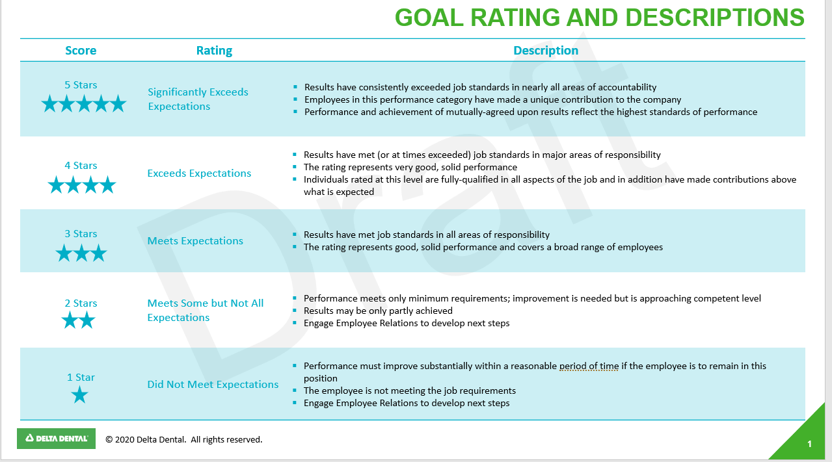

**Ratings Competencies**

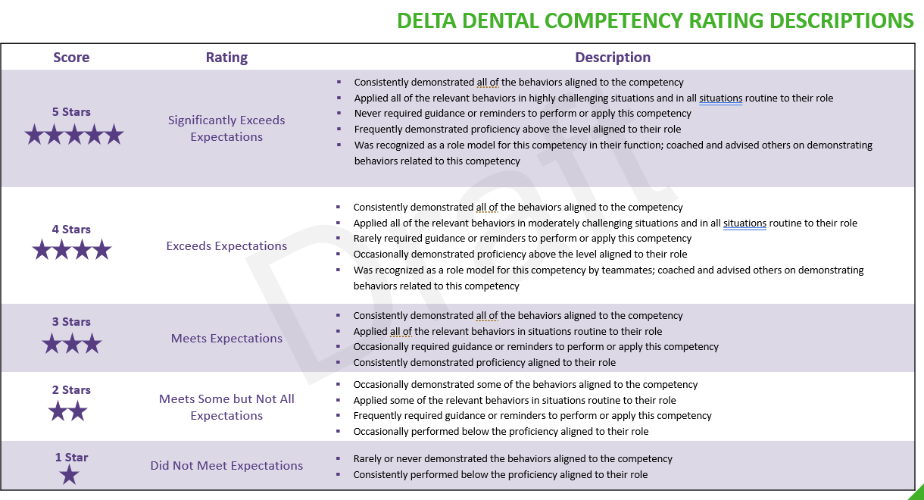

### Leadership behaviors definitions continued